ANDASIBE ANALAMAZAOTRA PARK

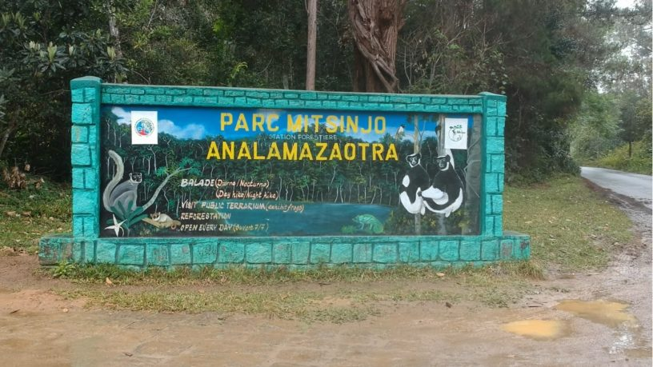

The national park offers a wide variety of endemic animal and plant species to discover during a circuit to the East Coast.
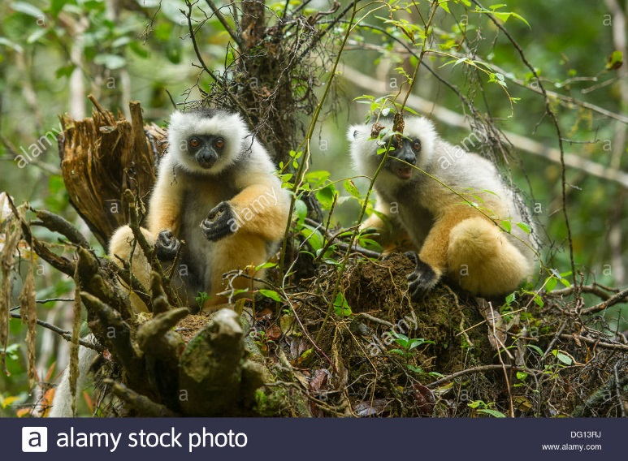

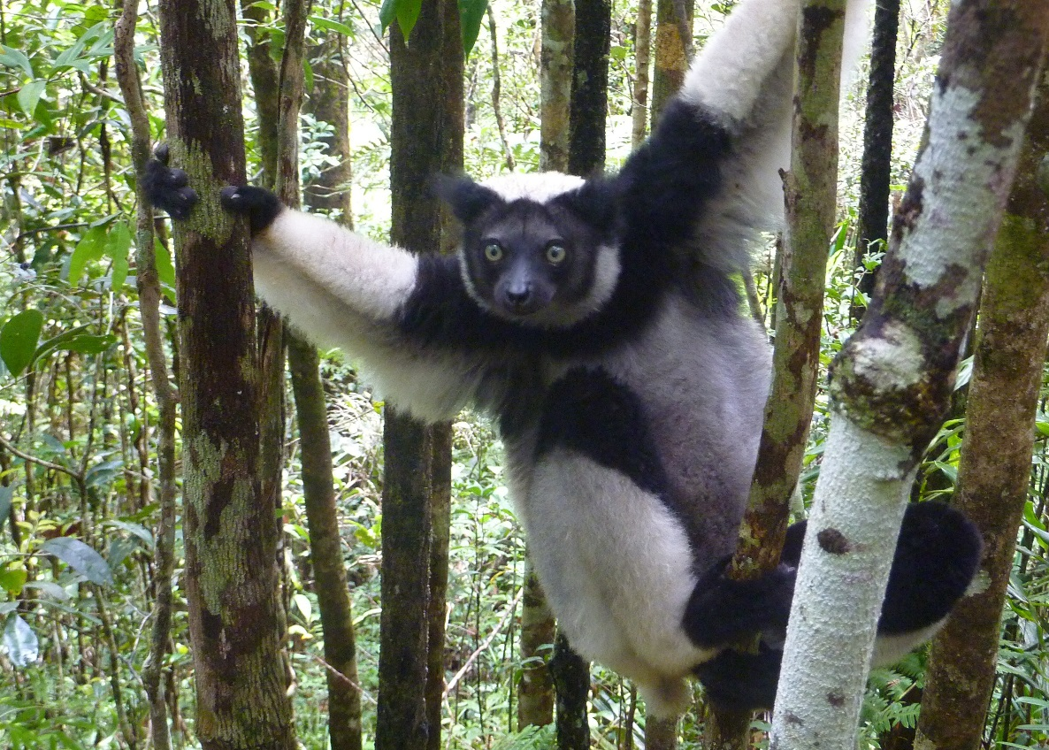

The Indri Indri is biggest lemur in Madagascar, one of the most popular species that we can see in Analamazaotra park.

MOST POPULAR HOTEL AND RESTAURANT:
- l'ANALAMAZAOTRA HÔTEL :OUTDOOR POOLS,All rooms include a wardrobe, bathroom with free toiletries, and some rooms at ANALAMAZAOTRA HOTEL also have garden views.

